Task 3: Architecture Design Challenge
Architecture Design of Amazon E-Commerce application
Traditional Data Warehouse:
The Traditional Data Warehouse Architecture collects structured data from transaction systems such as customer, inventory, CRM, and ERP databases. The data is processed using ETL (Extract–Transform–Load) and stored in a centralized relational database (e.g., Oracle, MySQL, SQL Server). It supports batch processing and generates reports and dashboards using BI tools like Power BI and Tableau. However, it mainly handles structured data and has limited scalability and real-time capabilities.

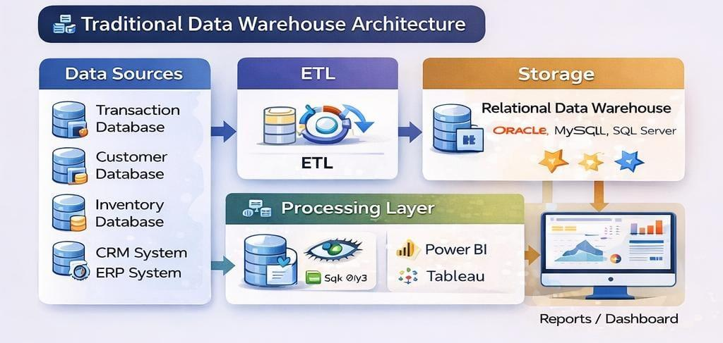

Hadoop-Based Big Data Architecture:
The Hadoop-Based Big Data Architecture collects structured, semi-structured, and unstructured data such as click logs, mobile app data, reviews, and social media. Data is ingested using tools like Kafka and stored in distributed systems like HDFS and Amazon S3. Processing is done using Spark and MapReduce, enabling real-time analytics, machine learning, recommendation systems, and predictive analysis. It supports horizontal scaling and handles massive data volumes efficiently.
